
COIT13230: Application Development Project
Assessment 1 - Project Proposal

UC/TUTOR: Farzad Sanati

Team members:
Prajita Bhandari
Akrishta Ale
Ayush Bhandari
Table of Contents
Phase 1: Project Discovery and Planning 4
Project Background and Justification 4
Background of the Project 4
Project Justification 4
Project Importance 5
Problem Statement 6
Current Problem 6
Issues with Current Customer Support Platforms 6
Gap Identified 7
Proposed Solution 7
Project's Goal 9
Expected Results 9
Project Objectives 10
Overview 10
SMART Project Objectives 10
Project Goals 10
Objectives of Technical Projects 11
Purposeful Summary 12
Vision of the project 12
Mission Statement 12
Expected Value 13
Long-Term Perspective 13
Innovative Features 13
Summary 13
AI-Powered Customer Support Chatbots 13
Priority and Automated Classification of Tickets 14
Analysing Customer Moods 14
Smart Human Escalation 14
Confidence Scoring in AI 14
Dashboard for Real-Time Analytics 15
Smart Knowledge Base 15
Human and AI Collaboration 15
Overview 15
Analysis of Stakeholders 16
Overview 16
Client 16
Support Officer 16
Administrator 16
Business Proprietor or Company 16
Development Team 17
AI Services Provider 17
Conclusion 17
User Roles 17
Clients 17
Support Agent 17
Administrator 18
Project Reach 18
Overview 18
In Scope 18
Out the Scope 18
Criteria for Success 19
Assumptions 19
Overview 19
Project Presumptions 19
Work Breakdown 20
Delivery Roadmap 21
Constraints 24
General Information 24
Limitations of the Project 24
Risk Identification and Mitigation Plan 25
Phase 2: Requirements Engineering 26
Functional and Non-Functional Requirements 26
Functional requirements 26
Non-functional requirements 28
System Analysis and Design 29
Introduction 29
System Design 33
Use Case Diagram 33
Context Diagram 33
High-Level Architecture / Component Diagram 34
Class Diagram 34
Sequence Diagram (AI chatbot interaction and escalation) 35
Activity Diagram 36
ERD Diagram 37
Deployment Diagram 38
Data Flow Diagram (DFD Level-0) 39
State Diagram 40
Conclusion 41
Reference 41
Individual Contribution Declaration 41
Team Collaboration Statement 42
AI Collaboration Declaration 42

Phase 1: Project Discovery and Planning

Project Background and Justification

Background of the Project

Nowadays, in the very competitive digital world, client service has become a crucial component influencing a business's prosperity. Every day, businesses in industries like retail, banking, healthcare, education, and e-commerce get a lot of customer questions through online channels. Regardless of location or time, customers demand more immediate, precise, and customized responses. (Reis, 2026)

However, a lot of companies continue to use outdated customer service procedures where human representatives categorize support requests, answer questions, and address problems. Although this strategy may provide individualized support, it becomes ineffective when handling a lot of monotonous questions. Frequently, staff members spend valuable time answering typical customer inquiries about product information, account troubles, order monitoring, service availability, and technical assistance. (Shimon Uzan, Freud and Amir Elalouf, 2025)

Among the issues that come with manual customer service procedures are:

- extended wait times for customers
- Support staff has a higher workload.
- Higher cost of doing business
- Different reactions from support staff
- Difficulty locating urgent consumer issues
- poor ability to evaluate service patterns and customer behaviour
(Reis, 2026)

Businesses need smart solutions that can respond more quickly while maintaining service quality as consumer expectations continue to grow.

Opportunities to revolutionize conventional customer care systems have been made possible by recent developments in artificial intelligence (AI), natural language processing (NLP), and machine learning technologies (Olujimi and Ade-Ibijola, 2023). Support systems powered by artificial intelligence can comprehend customer messages, offer automated responses, evaluate client sentiment, categorize inquiries, and help human agents in resolving challenging problems. (Journal of Science Engineering Technology and Management Science, 2
26)

The goal of the planned AI-Based Customer Support Automation System is to build a smart web-based platform that incorporates automated ticket management, sentiment analysis, business analytics, and AI chatbot technology (Reis, 2026). Customers will be able to get quick assistance for frequent questions with this method, and complicated problems will be forwarded to human support agents as needed. (Hybrid Human-AI Collaboration Models for Digital Workplace Optimization, 2025)

Project Justification

Increasing client care requests are problematic for several firms. Customer queries are frequently similar and follow identifiable trends. Examples are:

- Questions that are asked frequently
- Requests for a password reset
- Requests for product information
- Status inquiries for orders
- Simple troubleshooting concerns
- Questions pertaining to service
(Zangari et al., 2023)
(Asbjørn Følstad and Marita Bjaaland Skjuve, 2019)

These queries are handled manually, which puts needless strain on customer support representatives and limits the amount of time they have to address more challenging consumer issues. (Brandtzaeg and Følstad, 2017)

By automating repetitive support activities and improving the overall efficiency of customer service operations, the suggested AI-Based Customer Support Automation System offers a solution. To offer quick responses, categorize consumer requests, assess customer emotions, and suggest relevant actions, the system will employ AI technology. (Dlodlo and Sibanda, 2023) (Mao, Liu and Zhang, 2024)

The initiative offers a variety of commercial benefits:

Enhanced Customer Experience

By using an AI chatbot that is accessible at all times, consumers will receive answers more quickly. This improves overall satisfaction and reduces waiting times. (Rust, 2019)

Less Labor for Employees

Support professionals may concentrate on complicated problems that need human judgement and specialized knowledge by automating repetitive questions. (Shimon Uzan, Freud and Amir Elalouf, 2025)

Enhanced Operating Effectiveness

Organisations will be able to manage support requests more efficiently thanks to automated ticket classification and prioritization. (Dlodlo and Sibanda, 2023)

Making Decisions with Data

The analytics dashboard will offer insightful information on service patterns, reaction performance, and customer problems. (Taherdoost and Madanchian, 2023)

Competitive Advantage and Innovation

Businesses can stay competitive in an increasingly digital market by using AI technologies to update their customer care procedures. (Reis, 2026)

All in all, this endeavour is justifiable since it solves real-world customer care issues by combining human support procedures with artificial intelligence. The system improves the capabilities of customer care professionals and enables companies to offer more intelligent, quick, and effective assistance rather than taking their place. (Gnewuch, Morana and Maedche, 2017)

Project Importance

The initiative is consistent with current digital transformation trends in which businesses are more frequently using AI-based technology to enhance company operations (Pedro, Joao and Faria, 2024). AI has become a crucial instrument for automating routine chores, improving decision-making, and increasing client participation. (Kitsios and Kamariotou, 2021)

The actual usage of ideas from project management, web development, database management, software engineering, and AI is shown in this project. Organisations looking to improve their customer support operations can adapt the practical approach it offers. (Gnewuch, Morana and Maedche, 2017)

Problem Statement

Current Problem
Maintaining customer satisfaction and long-term customer ties in contemporary corporate environments requires strong customer support (Huang and Rust, 2023). However, many companies continue to have trouble handling a high volume of client questions successfully. (Dwivedi et al., 2021)

Traditional customer care systems typically rely on people to manually read, categorize, rank, and answer customer requests. These manual processes become inefficient and create many operational issues as the number of customer interactions rises. (Zangari et al., 2023)

Customers often need help with common questions like:

- Details about the item
- account problems
- tracking orders
- Resetting your password
- Refund applications
- Technical assistance
- Questions about services in general
(Følstad and Skjuve, 2019)

Even though many of these questions are repetitive and follow similar patterns, they still need to be handled manually. As a result, client care teams dedicate a lot of time to routine activities rather than concentrating on intricate issues that demand human competence. (Brandtzaeg and Følstad, 2017)

Issues with Current Customer Support Platforms

Organizations face several challenges with the existing customer support method:

Challenge | Description | Business Impact
High Response Time | Customers may experience delays while waiting for available support agents. | Reduced customer satisfaction and increased complaints.
Increased Workload | Support agents spend large amounts of time answering repetitive enquiries. | Lower productivity and increased operational costs.
Manual Ticket Classification | Customer requests are manually categorised and assigned priority levels. | Slower issue resolution and inefficient resource allocation.
Limited Availability | Human support teams may only operate during business hours. | Customers cannot receive immediate assistance outside working hours.
Inconsistent Responses | Different support agents may provide different answers to similar questions. | Reduced service quality and customer trust.
Difficulty Managing Peak Periods | Large enquiry volumes can overwhelm support teams. | Increased waiting times and unresolved requests.
Lack of Customer Insights | Businesses may not effectively analyse customer behaviour and feedback. | Missed opportunities for improving services.

Gap Identified

Despite offering fundamental communication and ticket management features, many current customer support systems fall short of intelligent automation capabilities.

Existing systems frequently fall short of offering:

- Using Natural Language Processing to comprehend customer questions automatically (NLP)
- Customer requests are expertly categorised.
- Automatic customer emotion and frustration level detection
- Frequently asked questions answered with AI.
- Ticket urgency forecasting
- Decisions made about sensible escalations
- analytics for real-time customer support

This causes businesses to still rely heavily on manual operations, which restricts scalability and efficiency.

An intelligent customer support solution is required that can automate routine interactions while also supporting human agents in dealing with difficult customer situations.

Proposed Solution

By creating an intelligent platform that combines Artificial Intelligence, Natural Language Processing, automated ticket management, and analytics, the suggested AI-Based Customer Support Automation System seeks to address these difficulties.

The following fixes will be provided by the system:

Customer Chatbot powered by AI

With natural language, an intelligent chatbot that can engage with customers will be part of the system.

The chatbot will:

Be aware of what the client is asking.
Offer automated answers
Respond to common inquiries
Walk customers through the steps of basic troubleshooting.
Collect Information Prior to Raising Support Tickets

Customers will be able to receive prompt help without having to wait for a human agent thanks to this.

Automatic Ticket Classification and Management

When the chatbot is unable to handle a customer problem, a support ticket will be generated immediately by the system.

The program will:

- Customer requests should be categorized.
- Give priority levels
- Save customer discussions.
- Monitor the status of tickets.
- Alert the proper support staff.

This boosts workflow effectiveness and guarantees that significant problems are addressed correctly.

Feeling Analysis

The system will analyse client messages to determine emotions such as:

- Happiness
- perplexity
- Disappointment
- pressing need
- Criticism

Understanding client issues and giving priority to sensitive cases will be aided by this information for support staff.

Rational Human Escalation

Human support will not be completely replaced by AI automation. Instead, the system will determine when human involvement is needed.

Escalation can happen when:

- The AI confidence rating is low.
- The customer has a difficult problem
- Negative feelings are observed
- There are many unsuccessful chatbot talks.

When automation is not enough, this makes sure that clients get the help they need.

Reporting and Analytics Platform

Insights into customer service performance will be made available to administrators through the system.

The dashboard will show:

- Number of inquiries received
- Types of tickets
- Typical response time
- Rate of resolution
- Trends in consumer satisfaction
- Performance of a chatbot
- Frequently encountered client issues

Businesses may use these insights to make educated decisions and keep improving their customer care.

Project's Goal

This project's goal is to create and develop an AI-powered customer service automation system that improves the quality, accessibility, and effectiveness of customer service processes.

The project seeks to strike a balance between AI and human assistance by utilizing AI to handle repetitive inquiries and freeing up human agents to concentrate on challenging consumer issues.

The technology will offer organizations a flexible solution that can accomplish the following:

- Reduce the waiting period for customers.
- Increase the effectiveness of support.
- Minimize duplicate tasks
- Improve customer satisfaction
- Give worthwhile commercial information

Expected Results

At the conclusion of the project, the expected results are as follows:

Outcome Description
Functional AI Chatbot A chatbot that can manage typical customer questions.
A ticket management system that automates support workflows and reduces manual labor.
Increased Responsiveness Compared to conventional assistance approaches, response times are faster.
Better Issue Prioritization Using automated ticket classification and priority assignment.
Service performance statistics are displayed on an analytics dashboard that generates customer insights.
Effective escalation method between AI and support representatives for human-AI cooperation.

Summary
The inefficiency of conventional customer support methods in addressing growing consumer expectations is the problem that this project aims to solve. Delays, higher operational costs, and lower customer satisfaction are all caused by manual procedures. The planned solution enhances customer experience and business efficiency by implementing AI-powered automation, NLP, sentiment analysis, and intelligent ticket management.
Businesses receive many customers support requests every day. Handling these manually increases response time, operational costs, and customer frustration. This system uses AI to automatically answer common questions, classify tickets, analyse sentiment, and escalate complex issues to human agents.

Project Objectives

Overview

The main objective of the AI-Based Customer Support Automation System is to develop and build an intelligent customer service platform that uses Artificial Intelligence (AI) and Natural Language Processing (NLP) technologies to automate routine client interactions, increase support efficiency, and boost customer satisfaction.

By enabling AI to manage repeated questions and making sure complex problems are transferred to human agents when necessary, the project seeks to establish a system that aids both support agents and customers.

The SMART approach was used to outline the objectives to ensure that they are concrete, measurable, attainable, pertinent, and time bound.

SMART Project Objectives

Objective | Description | Measurement
Develop an AI-powered chatbot system | Create a chatbot capable of understanding customer enquiries and providing automated responses using AI and NLP technologies. | The chatbot successfully responds to common customer questions and completes basic support interactions.
Automate customer support ticket management | Develop a system that automatically creates, categorises, prioritises, and tracks customer support tickets. | Customer enquiries are automatically converted into organised tickets with appropriate categories and priorities.
Reduce customer response time | Improve customer service efficiency by providing immediate AI-generated responses for frequently asked questions. | Target response time of less than 3 seconds for chatbot-generated responses.
Implement sentiment analysis capabilities | Develop a feature that analyses customer messages to identify emotional tone and urgency. | System accurately identifies positive, neutral, and negative customer sentiment.
Provide intelligent human escalation | Create an escalation mechanism that transfers complex or unresolved issues to human support agents. | High-priority or low-confidence AI responses are successfully escalated.
Develop an analytics dashboard | Create a dashboard that provides insights into customer support performance and system usage. | Administrators can view ticket statistics, chatbot activity, and customer service trends.
Improve support agent efficiency | Reduce repetitive tasks performed by support staff by automating common customer interactions. | Agents spend more time resolving complex cases rather than answering repeated questions.
Ensure system security and reliability | Implement appropriate security measures to protect customer information and maintain system availability. | User authentication, data protection, and secure communication are successfully implemented.
Deliver a functional prototype within the semester timeframe | Complete the system development process according to the project schedule and assessment requirements. | All major project components are completed within the 12-week development period.

Project Goals
The project will concentrate on reaching the following objectives:
Objective 1: Cut down on the amount of time it takes to respond to consumers.
Customers will be able to get support without waiting for an open support staff member thanks to the system's instant automated aid provided via an AI chatbot.
Expected outcomes:
- Quicker consumer responses
- Increased client satisfaction
- Delayed Support Reduced
- Better service access
Objective 2: Reduce the Workload of the Support Team
The system will automate regular client contacts, freeing up support personnel to concentrate on difficult issues that need human assessment.
Expected Outcomes:
- Better staff output
- Lowered duplicate tasks
- Support resources should be allocated more effectively.
- Greater operational effectiveness

Objective 3: Optimize Ticket Handling
Automated ticket generation, categorization, priority setting, and tracking will be provided by the system to enhance support processes.
Expected outcomes:
- Improved management of client concerns
- Key request resolution is faster.
- Improved Support Monitoring
- Minimized unresolved tickets

Objective 4: Offer Smart Client Insights
Organizations will be able to comprehend customer behaviour and raise service quality thanks to the analytics dashboard.
Expected outcomes:
- Common client issues are being identified.
- Observing trends in client satisfaction
- Assessing the efficacy of chatbots
- Better business choices

Objectives of Technical Projects

The project hopes to accomplish these technological objectives:
- Make a responsive, web-based support program for customers.
- A chatbot powered by artificial intelligence that can perform the following tasks should be developed:
- Understanding client questions
- Creating automated answers
- Providing FAQ help
- Encouraging Client Interaction
- Create a ticket management system that allows you to:
- Create tickets
- Classification of tickets
- Assignment of priority
- Tracking Tickets
- Integrate AI technologies for:
- the processing of natural language
- Analysis of sentiment
- Automated response production
- Smart expansion
- Create an analytics dashboard that offers:
- Statistics for client support
- Ticket developments
- Response time information
- Insights on System Usage
- Make sure the following testing steps are in place:
- Correctness in function
- Safeguarding
- Performance
- Usability

Purposeful Summary

By incorporating intelligent automation, boosting operational efficiency, and elevating customer experience, the goals of the AI-Based Customer Support Automation System are designed to overcome present customer service challenges.
The project will provide a helpful AI-driven support solution that assists businesses in controlling escalating consumer demands while preserving effective human support skills by fulfilling these goals.

Vision of the project

Mission Statement

The purpose of the AI-Based Customer Support Automation System is to create an intelligent and effective customer support platform that employs Natural Language Processing (NLP) and Artificial Intelligence (AI) to enhance customer service experiences.

The system aims to help human agents manage complex customer issues, improve response times, reduce workload on support teams, and automate repetitive customer questions. The project will give organizations a cutting-edge and efficient way to handle client interactions by integrating human assistance with AI automation.

Objectives for the Project Vision

The project is intended to:

- Use an AI chatbot to offer quicker customer support.
- By automating common inquiries, customer support representatives may lessen their workload.
- Automate ticket categorization and prioritization to increase support effectiveness.
- By offering regular and accurate answers, you may improve client pleasure.
- Customer service statistics may help improve decision-making.
- Create productive cooperation between human support workers and AI systems.

Expected Value

The suggested system will provide value to several stakeholders:

Stakeholder | Description
Customer | Uses the chatbot and creates support tickets
Support Agent | Handles tickets that need human assistance
Administrator | Manages users, tickets, and system settings
Business Owner / Company | Wants faster support and better customer satisfaction
Development Team | Designs, builds, tests, and maintains the system
AI Service Provider | Supplies the AI model (OpenAI or Gemini API)

Long-Term Perspective

To create a scalable AI-driven customer care solution that can consistently improve with technological progress and shifting company needs is the system's long-term objective.

Future upgrades might include:

- Customer care in several languages.
- Assistance via voice-based AI.
- Interoperability with CRM systems.
- sophisticated predictive analytics to pinpoint client problems.
- Updated knowledge base for Ongoing improvement of AI responses.

The project's goal is to assist companies in providing more customized, intelligent, and quick customer care experiences.

Innovative Features

Summary

The AI-Based Customer Support Automation System combines data analytics, automation, natural language processing (NLP), and artificial intelligence (AI) to introduce a number of innovative features that enhance standard customer support procedures.

This initiative prioritizes intelligent automation, even while maintaining human engagement for challenging customer problems, in contrast to traditional support systems that mostly utilize manual ticket handling.

AI-Powered Customer Support Chatbots

An intelligent chatbot that can converse with customers in natural language will be part of the system.

These are some of the key capabilities:

- Natural Language Processing (NLP) is used to interpret customer inquiries.
- Responding to often asked questions automatically.
- Helping customers with basic difficulties such as account questions, product information, and service requests.
- Delivering immediate support without needing human agent presence.
- Faster responses improve the customer experience.

Priority and Automated Classification of Tickets

By analysing consumer messages and creating appropriate tickets, the system will automatically handle requests for customer support.

Among the features are:

- Based on problem type, customer questions are automatically sorted into groups.
- Categorizing priority levels based on customer impact and urgency.
- Reducing the need for manual ticket organization.
- Supporting assistance agents to prioritise vital problems.

Analysing Customer Moods

Customer communications will be examined by the system to determine customer satisfaction levels and emotional reactions.

The feature will:

- Recognize whether the customer sentiment is positive, neutral, or negative.
- Find frustrated or dissatisfied clients.
- Before responding, assist support agents in understanding customer sentiments.
- Give crucial or sensitive topics more attention right away.

Smart Human Escalation

By pinpointing scenarios that need human input, the system will mix human assistance with AI automation.

Escalation choices will be made on the following factors:

- Level of confidence in AI to produce a response.
- The customer's question's complexity.
- Negative feelings toward the customer.
- Numerous chatbot interactions that failed.

In order to guarantee that consumers get the right help, the automation system must be kept as efficient as possible.

Confidence Scoring in AI

Prior to providing responses to customers, the system will assess the degree of certainty in AI-generated answers.

The following are some advantages:

- Reducing AI replies that are inaccurate.
- Improving response accuracy.
- Determining which situations demand human assistance.
- Enhancing consumers' confidence in AI-powered customer support.

Dashboard for Real-Time Analytics

Administrators will have access to a dashboard to keep an eye on customer support operations.

It will be shown on the dashboard:

- The number of customer questions.
- Priorities and ticket categories.
- Resolution and response times.
- Customer sentiment tendencies.
- Performance statistics for the chatbot.

These insights will allow organizations to pinpoint prevalent client pain spots and enhance assistance methods.

Smart Knowledge Base

There will be support materials, frequently asked questions, and solutions in the system's knowledge base.

The knowledge base will:

- Ensure that chatbot responses are factually correct.
- Lessen repeated client questions.
- Promote quicker issue resolution.
- Enable the constant improvement of AI responses.

Human and AI Collaboration

One of the project's most important innovations is the integration of AI automation with human knowledge.

The system will:

- Let AI take care of monotonous tasks.
- Help human representatives with well-organized client data.
- When necessary, raise complex cases.
- Enhance overall customer service effectiveness.

Overview

The goal of the Artificial Intelligence-based Customer Support Automation System's cutting-edge capabilities is to improve customer interaction, decision-making, and intelligent automation in order to revolutionize conventional customer service. With the use of AI chatbot technology, sentiment analysis, automated ticket management, and analytics, companies may offer customers a support solution that is more effective and customer-focused.

Analysis of Stakeholders

Overview
Stakeholders are people, groups, or organizations that have an interest in the AI-Based Customer Support Automation System's development, deployment, or usage. It's critical to comprehend the demands of stakeholders in order to make sure the system achieves business objectives and offers value to all users.
The main parties engaged in this project include:

Client
The main customers that communicate with the AI-powered support system are customers.
Their interests and responsibilities are:
- Obtaining support and asking questions using the AI chatbot.
- When problems cannot be resolved automatically, support tickets should be created.
- Looking for prompt, precise, and dependable replies.
- Taking advantage of better customer care availability and speedier issue resolution.

Support Officer
Customer support agents are in charge of addressing problems that demand human intervention.
Their duties and interests include:
- Handling escalated customer support concerns.
- Offering fixes to challenging client issues.
- Using system information to comprehend client issues.
- Increasing productivity by utilizing AI-powered support capabilities.
- Less time spent on recurrent questions.

Administrator
The system must be managed and maintained by administrators.
Among their interests and duties are:
- User accounts and access rights are managed.
- Examining customer service initiatives.
- Handling system settings and tickets.
- Examining performance and analytics data.
- Making sure the system runs well.

Business Proprietor or Company
The system's implementation benefits primarily the business owner or organization, who is the primary stakeholder.
Their interests and duties are:
- Service quality and customer satisfaction are being improved.
- Lowering the cost of running manual assistance procedures.
- improving the effectiveness of customer service operations.
- Enhancing business choices by utilizing information gathered from analytics.
- Maintaining a competitive edge via the implementation of AI.

Development Team
The system's design, development, testing, and maintenance are the responsibility of the development team.
Their duties and interests include:
- System requirements analysis.
- Creating the user interface and system architecture.
- creating AI, backend, frontend, and database parts.
- executing debugging and testing.
- Confirming that the system adheres to project specifications and quality requirements.

AI Services Provider
The AI service provider provides the artificial intelligence technology needed for chatbot capabilities.
Their interests and responsibilities are:
- Giving users access to AI models like the Gemini API or OpenAI.
- Assisting in the capabilities of natural language processing.
- Making sure that AI services are constantly available.
- Improving and sustaining AI model performance.

Conclusion
To ensure the success of the AI-Based Customer Support Automation System, the needs of all stakeholders must be met. Customers get quicker support, businesses become more efficient, support personnel have access to better tools, and the development team ensures that the system is successfully delivered.

User Roles
Different sorts of users, each with certain duties and access rights, will be supported by the AI-Based Customer Support Automation System. Customers, support agents, and administrators are among the primary user roles.

Clients

The main users who engage with the system to get support and handle their questions are clients.
Customers will be able to accomplish the following:

- Create an account.
- Access the system with assurance.
- Use the AI chatbot to get in touch with it.
- Get automated answers to popular questions.
- When more assistance is needed, create support tickets.
- See how tickets are being processed and what their current status is.

Support Agent

Customer problems needing human help are handled by support personnel.
Agents will be capable of:

- Use a secure login to access the system.
- See which customer support tickets have been assigned.
- Examine details of concerns and client talks.
- Respond to client questions.
- Offer remedies for challenging issues.
- Shut off tickets that have been resolved and update them.

Administrator

Administrators are in charge of monitoring customer service operations and overseeing the whole system.
Administrators will be able to perform the following tasks:

- Access administrative operations by logging in.
- Handle permissions and user accounts.
- System actions should be monitored.
- Access client support statistics via the dashboard.
- Create reports on customer questions and support performance.

Project Reach

Overview

The features and functions that will be part of the creation of the AI-Based Customer Support Automation System are defined in the project scope. It guarantees that the project stays concentrated on delivering the necessary capabilities within the given timeframe and resources.

In Scope

The project will include the following features:

- Creation of accounts and user registration.
- Authentication and safe user login.
- AI chatbot that responds to consumer questions.
- Creating and handling support tickets.
- According to consumer requests, categorize tickets automatically.
- Analysis of customer sentiment to determine levels of satisfaction and urgency.
- A customer issue management interface for support professionals.
- System performance can be monitored through the administrator dashboard.
- Analytics and reports pertaining to customer care operations.

Out the Scope

The following features will not be part of the current project because of limits on time and resources:

- Creating a smartphone application.
- Features of an AI assistant that is voice-activated.
- Customer assistance via video.
- Support for multiple languages.
- Integration of financial transactions or payment processing.
- After the initial system is finished, these elements may be regarded as future upgrades.

Criteria for Success

The fulfillment of crucial business and functional objectives will serve as the basis for assessing the AI-Based Customer Support Automation System's efficacy.

The project will be deemed successful if:

- The system allows users to successfully register and securely log in.
- The AI chatbot is able to provide precise answers to typical customer questions.
- Customers may effectively create and monitor support requests.
- Agents may view, manage, respond to, and resolve customer support tickets.
- The dashboard allows administrators to see how effectively customer service is performing.
- The analytics dashboard provides valuable information about support activities and client interactions.
- The system runs without fail and fulfills all necessary quality criteria.

Assumptions

Overview

Conditions that are anticipated to hold true throughout the creation and deployment of the AI-Based Customer Support Automation System are known as project assumptions. By identifying things that could affect the project's success and making it easier to plan, these assumptions are helpful.

The following hypotheses have been taken into account:

Project Presumptions
- The members of the development team will complete their allotted project tasks within the allotted period and make significant contributions.
- Throughout the duration of the project, all of the necessary platforms, frameworks, and tools for software development will be accessible.
- The web-based customer support system will be available to users through a dependable internet connection.
- The AI service provider (like OpenAI or Gemini API) will continue to be accessible and offer trustworthy AI functionality throughout testing and development.
- It will be possible to process customer data that has been input into the system because it will be correct and appropriate.
- The project needs established during the planning phase will remain reasonably consistent throughout development.
- Team members will either have enough technical expertise to do development duties or access to educational resources that do.
- System evaluation will be performed using available hardware resources and testing environments.
- The database system will be capable of storing all necessary information regarding customers, tickets, and system activity.

Work Breakdown
Akrishta Ale – Frontend Developer & UI/UX Lead
Akrishta is responsible for the frontend development and user interface design aspects of the project. Her main contributions include:
- Designing the overall user interface structure and ensuring a user-friendly experience.
- Developing the frontend application using React.js.
- Creating responsive web layouts using HTML5 and CSS3.
- Implementing customer-facing pages including:
  - Login and registration interfaces.
  - Customer dashboard.
  - AI chatbot interface.
  - Ticket submission and ticket status pages.
  - Admin dashboard interfaces.
- Learning and applying React components, React Router, and API integration techniques.
- Connecting frontend components with backend REST APIs.
- Performing frontend testing, debugging, and improving usability.
- Contributing to project documentation, proposal preparation, MS Project scheduling, and Gantt chart development.
- Managing GitHub repository activities related to frontend code and project documentation.

Prajita Bhandari – Backend Developer & Database Lead
Prajita is responsible for backend architecture, database management, and server-side development. Her main contributions include:
- Designing and developing the backend system using Spring Boot.
- Creating and managing MySQL database structures.
- Developing REST APIs required for frontend communication.
- Implementing authentication and authorisation features using JWT.
- Developing backend modules including:
  - User management.
  - Ticket management.
  - Data processing services.
- Ensuring secure data handling and backend reliability.
- Performing backend testing and API validation using appropriate testing tools.
- Supporting system integration between backend services and frontend components.

Ayush Bhandari – AI Integration & Research Lead
Ayush is responsible for AI-related research, intelligent system features, and technical investigation. His main contributions include:
- Researching suitable AI service providers such as OpenAI or Gemini API.
- Designing AI chatbot workflows and conversation processes.
- Investigating Natural Language Processing (NLP) approaches.
- Developing AI features including:
  - Customer query understanding.
  - Automated response generation.
  - Ticket classification.
  - Sentiment analysis.
  - Escalation recommendations.
- Supporting AI and backend integration.
- Researching technical solutions and documenting AI-related components.
- Contributing to project requirements, user stories, and proposal development.

Delivery Roadmap

The project delivery roadmap has been developed using Microsoft Project to provide a structured timeline for planning, monitoring, and controlling project activities. The Gantt chart represents the sequence of project phases, task dependencies, assigned responsibilities, and major assessment milestones throughout the development lifecycle.
The project has been divided into five major sprints:
- Sprint 1: Project Proposal and Planning (Week 3–4)
Focuses on project definition, background research, requirements identification, risk planning, and completion of Assessment 1.
- Sprint 2: Requirements Engineering and Initial Design (Week 5–6)
Focuses on system design activities, backend setup, database planning, AI provider research, and initial frontend development.
- Sprint 3: Core System Development (Week 7–9)
Focuses on implementing backend APIs, AI functionality, frontend interfaces, and system integration.
- Sprint 4: System Integration and Enhancement (Week 10–11)
Focuses on connecting all modules, improving system performance, enhancing security, and refining user interfaces.
- Sprint 5: Testing and Final Delivery (Week 12–Exam Week)
Focuses on testing, debugging, documentation, final review, and project presentation preparation.

The Gantt chart below illustrates the planned project timeline, task dependencies, resource allocation, and key milestones including Assessment 1 submission, progress reports, final report submission, and final presentation.

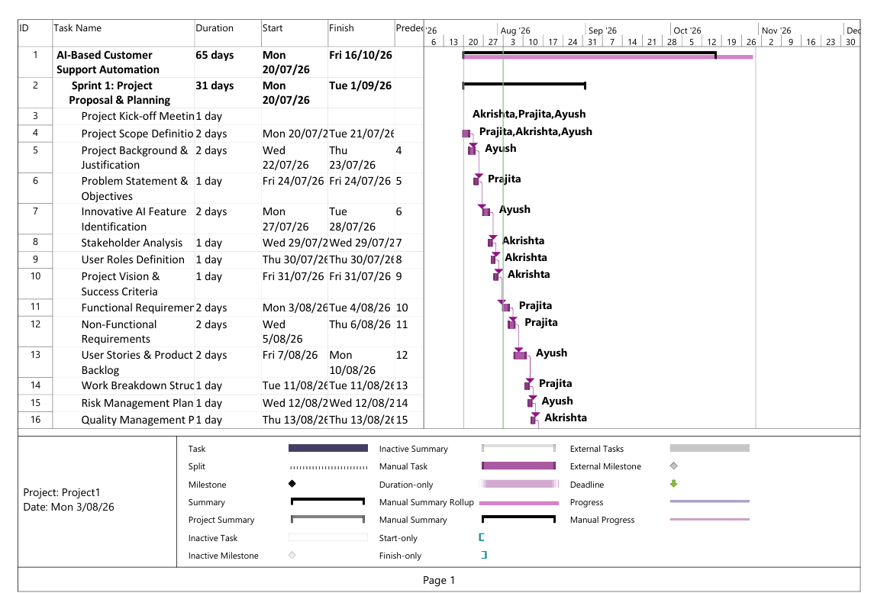
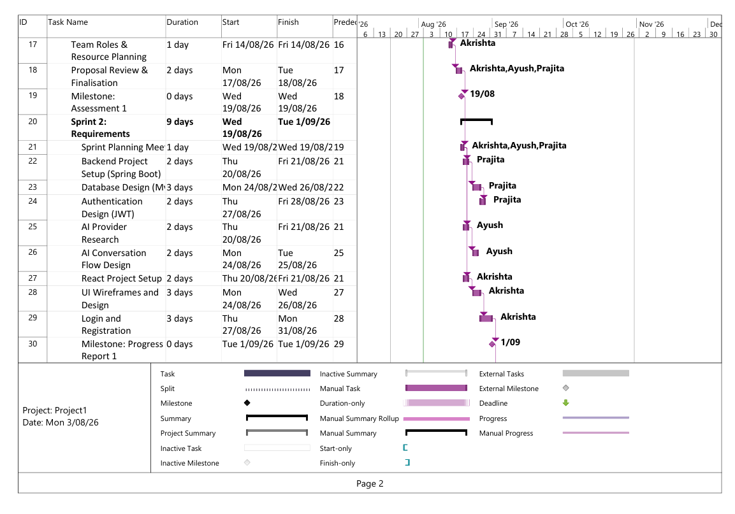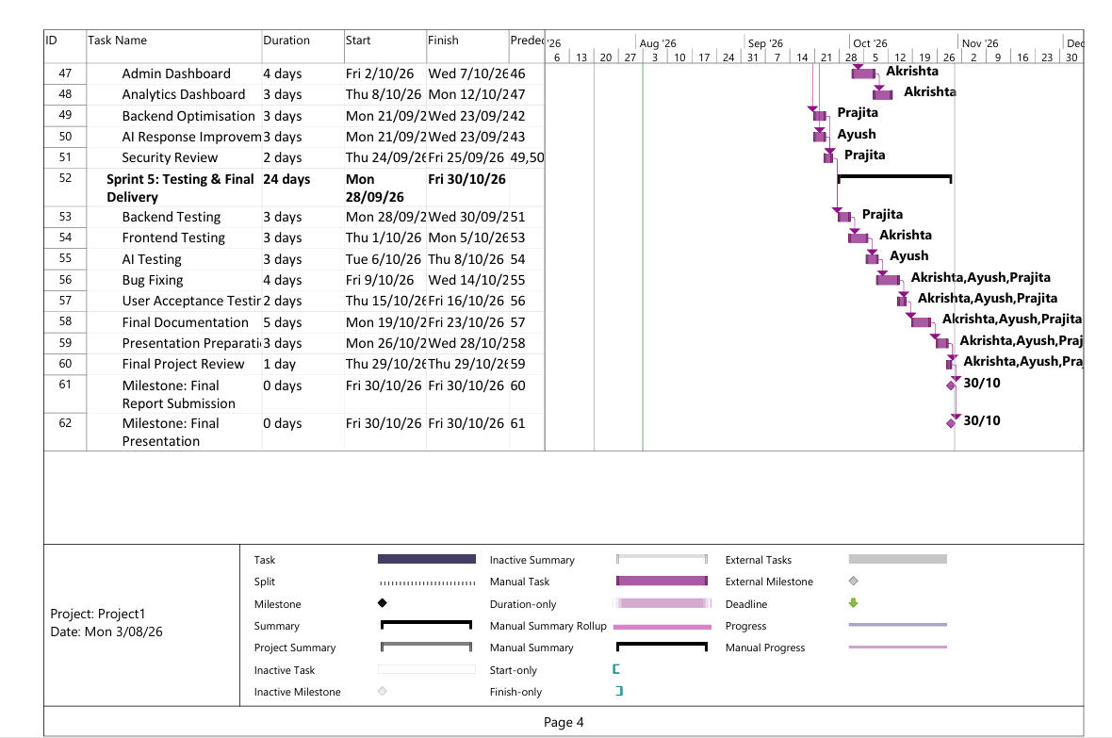

Constraints

General Information

Limitations or constraints that could have an impact on the AI-Based Customer Support Automation System's development, deployment, and delivery are considered project constraints. The team may manage expectations and lessen potential project issues by recognizing these limits.

Limitations of the Project
Time constraints
- The project needs to be finished within the semester's allotted time.
- Development efforts must adhere to the evaluation schedule and submission deadlines.
- It's possible that sophisticated features won't be implemented due to time constraints.

Team Constraints
- With limited resources, a small staff will create the project.
- Members of a team could have varying levels of technical knowledge.
- In order to finish the assignment properly, there must be good communication and cooperation.

Technical Constraints
- The system relies on external AI services, such as OpenAI or the Gemini API.
- System performance may be impacted by API restrictions, availability concerns, or response delays.
- The project has to function with the resources and technologies that are already available.

Budget Constraints
- The available budget for software tools, APIs, and cloud services is constrained because this is an academic endeavour.
- Where possible, open-source or student-accessible tools may need to be used.

Scope Constraints
- The goal of the project is to create a web-based client service system.
- Currently, advanced features like mobile apps, speech assistants, and multilingual support are not included.

Security Constraints
- User information must be safeguarded by the system, and access must be secured.
- Enterprise-level security features might not be entirely implemented because of project limitations.

Risk Identification and Mitigation Plan
Effective risk management helps minimise project disruption and improves the likelihood of successful project completion. The following table identifies potential project risks, their likelihood and impact, together with mitigation strategies and contingency actions.

Risk | Likelihood | Impact | Mitigation Strategy | Contingency Plan
AI API becomes unavailable | Medium | High | Use stable APIs, monitor service status, implement error handling | Switch to another AI provider (e.g., Gemini or OpenAI) or temporarily use predefined FAQ responses
AI API rate limits exceeded | Medium | High | Optimise API requests, cache common responses | Delay non-essential requests or upgrade API plan if feasible
Team member becomes unavailable | Medium | High | Distribute knowledge among all members and document progress | Reassign tasks to other members and adjust sprint schedule
Project falls behind schedule | Medium | High | Follow Agile sprints and monitor weekly progress | Prioritise essential features and postpone optional features
Integration issues between frontend, backend, and AI | Medium | High | Test APIs early and perform continuous integration | Allocate additional debugging time and simplify integration where necessary
Database failure or data corruption | Low | High | Perform regular backups and validate database operations | Restore data from backup and recreate affected records if required
Security vulnerabilities | Medium | High | Implement password encryption, JWT authentication, and input validation | Apply security patches, fix vulnerabilities, and retest before deployment
Poor AI response accuracy | Medium | Medium | Improve prompts, test different scenarios, and refine chatbot responses | Escalate conversations to human support agents when AI confidence is low
Internet connectivity issues | Low | Medium | Use reliable internet and cloud services | Continue offline development and resume testing once connectivity is restored
Requirement changes during development | Medium | Medium | Confirm requirements during Sprint 1 and obtain team agreement | Assess the impact of changes and update the project plan if necessary
Software bugs discovered during testing | High | Medium | Conduct unit, integration, and system testing throughout development | Prioritise bug fixes based on severity before final release
Loss of project files or code | Low | High | Use GitHub version control with regular commits | Recover previous versions from the Git repository

Phase 2: Requirements Engineering

Functional and Non-Functional Requirements

Functional requirements
Functional requirements describe what the system must do. They are derived from the problem statement, proposed solution, user roles, and project objectives in your proposal.

Customer interaction and chatbot
- FR1: The system shall allow customers to register an account and authenticate securely before accessing the support interface.
- FR2: The system shall provide a web-based chat interface where customers can submit questions and messages.
- FR3: The system shall receive customer messages and process them using AI/NLP to understand the intent and content.
- FR4: The system shall provide automated responses to common customer questions (FAQs, order status, account queries, product information, general service questions).
- FR5: The system shall guide customers through simple troubleshooting steps when possible (e.g. password reset instructions, basic technical support).
- FR6: The system shall allow customers to view previous chatbot conversations and ticket message history.
- FR7: The chatbot shall remain available continuously whenever the system is operational.

Ticket creation and management
- FR8: The system shall automatically create a support ticket when the chatbot cannot fully resolve a customer inquiry or when the customer explicitly requests escalation.
- FR9: The system shall attach relevant information to each ticket, including customer identity, conversation history, category, priority, sentiment score, and time stamps.
- FR10: The system shall store all tickets in a persistent database.
- FR11: The system shall allow customers to view the status of their tickets (e.g. Open, In Progress, Resolved).

Automated ticket classification and prioritisation
- FR12: The system shall automatically classify tickets into predefined categories (e.g. Billing, Technical, Account, General Inquiry, Refund).
- FR13: The system shall assign priority levels (e.g. Low, Medium, High, Critical) based on factors such as issue type, sentiment, and urgency expressed by the customer.
- FR14: The system shall update ticket classification and priority if new customer messages change the context (e.g. increased frustration or urgency).

Sentiment analysis and confidence scoring
- FR15: The system shall analyse the sentiment of each customer message (e.g. positive, neutral, negative).
- FR16: The system shall compute an AI confidence score for each proposed automated response or ticket classification.
- FR17: The system shall flag tickets/messages with negative sentiment or low AI confidence for special handling or escalation.

Intelligent escalation to human agents
- FR18: The system shall determine when human intervention is required based on business rules (e.g. low confidence, complex queries, repeated chatbot failures, high priority, negative sentiment).
- FR19: The system shall escalate tickets to support agents by assigning them to human users with the appropriate role.
- FR20: The system shall notify support agents of newly escalated tickets (e.g. through dashboard updates or alerts).
- FR21: The system shall allow support agents to view escalated tickets, read conversation history, and respond manually to customers.
- FR22: The system shall allow support agents to update ticket status (e.g. In Progress, Resolved, On Hold) and add resolution notes.

Knowledge base and FAQs
- FR23: The system shall maintain a knowledge base of FAQs and predefined responses used by the chatbot.
- FR24: The system shall allow administrators/support agents to add, update, or remove knowledge base entries.
- FR25: The system shall use the knowledge base to generate consistent and accurate automated responses to common questions.

Analytics and reporting
- FR26: The system shall provide an analytics dashboard for administrators to view support statistics, including:
- number of customer enquiries
- ticket counts per category and priority
- average response time and resolution time
- escalation rate (AI to human)
- customer sentiment trends
- chatbot success and failure rates
- FR27: The system shall allow admins to filter analytics by date range, ticket type, sentiment, and escalation status.
- FR28: The system shall generate summary reports (e.g. weekly or monthly) on customer support performance and common issues.

User management and roles
- FR29: The system shall support different user roles: Client, Support Agent, Administrator.
- FR30: The system shall provide registration and login functionalities for Clients and appropriate authentication for Agents and Admins.
- FR31: The system shall restrict access based on role (e.g. only Admins can view global analytics and manage users, only Agents can manage escalated tickets).
- FR32: The system shall allow administrators to manage user accounts (create, update, deactivate) and assign roles.
- FR33: The system shall record important events such as login attempts, ticket creation, escalation actions, and AI-generated responses in a system log.

Non-functional requirements
Non-functional requirements describe how the system should perform and the qualities it must have. They are based on your proposal’s sections on importance, constraints, assumptions, and expected value.

Performance
- NFR1: The system shall provide automated chatbot responses within an average response time of less than 3 seconds under normal load.
- NFR2: The system shall handle multiple concurrent customer sessions without significant degradation in response time, within the limits of available resources.

Reliability and availability
- NFR3: The system shall be able to handle invalid input and external AI service failures gracefully, returning appropriate error messages or fallback responses.
- NFR4: The system shall maintain integrity of ticket and conversation data, ensuring tickets are not lost or corrupted.
- NFR5: The system shall provide acceptable availability during defined operating hours; for the prototype, the system should be available whenever the server is running in the lab or test environment.

Security
- NFR6: The system shall protect user credentials using secure authentication mechanisms (e.g. hashed passwords, secure login).
- NFR7: The system shall use secure communication protocols (e.g. HTTPS in deployment) to protect customer data in transit where possible.
- NFR8: The system shall enforce role-based access control to prevent unauthorized access to admin and agent functionalities.
- NFR9: The system shall handle customer data according to privacy and data protection guidelines appropriate for an academic project.
- NFR10: The system shall encrypt stored customer information where practical to ensure data privacy and protection.

Usability
- NFR11: The user interface shall be intuitive and user-friendly, allowing customers to easily ask questions, view responses, and track ticket status.
- NFR12: The interface for support agents and administrators shall present information clearly, with understandable labels, tables, and charts.
- NFR13: The system shall be usable on common desktop web browsers, with responsive design where practical.

Scalability and extensibility
- NFR14: The system shall be designed in a modular way so that additional features (e.g. multilingual support, voice assistance, mobile apps, CRM integration) can be added in future without major redesign.
- NFR15: The AI components shall be abstracted behind service interfaces so that different AI providers (e.g. OpenAI, Gemini API) can be integrated or swapped as needed.

Maintainability
- NFR16: The system shall separate frontend, backend, AI logic, and data access into distinct components to facilitate maintenance and future updates.
- NFR17: The code shall follow readable naming conventions and basic documentation to assist future developers or team members.

Constraints and environment
- NFR18: The system shall be implemented using the technologies permitted by the unit (HTML, CSS, JavaScript frontend; Java Spring Boot REST API backend; relational database).
- NFR19: The system shall run within the available hardware, software, and external API limits of an academic environment (e.g. limited API calls, minimal hosting budget).
- NFR20: The system shall be deliverable within the semester timeframe and assessment deadlines.

System Analysis and Design

Introduction
The AI-Based Customer Support Automation System is an intelligent, web-based platform designed to automate routine customer interactions using an AI-powered chatbot, while enabling human support agents to manage complex issues. The purpose of System Analysis and Design is to translate the project proposal into a detailed technical specification that defines:
- What the system must do (functional and non-functional requirements)
- Who interacts with the system (stakeholders and actors)
- How the system behaves (use cases and workflows)
- How the system will be structured (architecture, components, and data model)
This section builds directly on the project background, problem statement, proposed solution, objectives, scope, stakeholders, assumptions, and constraints outlined in the Project Proposal. It converts high-level ideas into a concrete design that can be implemented using:
- Frontend: HTML, CSS, JavaScript
- Backend: Java Spring Boot REST API
- Database: Relational database (MySQL/H2)
System Context and Stakeholders
System Context
The system operates as a web-based application accessed through standard browsers. It interacts with:
- Clients, Support Agents, and Administrators via HTTP/HTTPS
- A relational database for persistent storage
- External AI services (e.g., OpenAI, Gemini API) for NLP, sentiment analysis, and classification
At a high level:
- Customers use a chat interface to ask questions and receive automated assistance.
- When automation is insufficient, the system creates and escalates tickets to human support agents.
- Administrators monitor system performance, manage users, and maintain the knowledge base.
This context aligns with the “Project Reach”, “User Roles”, and “Stakeholders” sections of the proposal.

Stakeholders and Roles
Stakeholders from the proposal map directly to system actors:
Stakeholder | System Actor | Description
Customer | Client | Uses chatbot, creates tickets, views ticket status
Support Agent | Support Agent | Handles escalated tickets, responds to complex issues
Administrator | Admin | Manages users, analytics, knowledge base
Business Owner / Company | — | Benefits from improved support efficiency and analytics
Development Team | — | Designs, builds, tests, and maintains the system
AI Service Provider | External AI Engine | Supplies AI/NLP capabilities
Primary system actors:
- Client
- Support Agent
- Administrator
- External AI Service
Use Case Analysis
Use cases describe how actors interact with the system to achieve their goals. They are derived from the project proposal’s features: AI chatbot, ticket management, sentiment analysis, escalation, analytics, and knowledge base.
Main Use Cases
UC1 - Register and Login
Actors: Client, Support Agent, Admin
Goal: Create an account or log in securely to access the system.
UC2 - Chat with AI Bot
Actor: Client
Goal: Ask questions and receive automated responses.
UC3 - Create Support Ticket
Actors: Client, System
Goal: Automatically or manually create a support ticket when an issue cannot be fully resolved by AI.
UC4 - Classify and Prioritise Ticket
Actors: System, AI Engine
Goal: Automatically assign category and priority to tickets using AI or rule-based logic.
UC5 - Analyse Sentiment and Confidence
Actors: System, AI Engine
Goal: Determine customer sentiment and AI confidence score to support escalation decisions.
UC6 - Escalate Ticket to Human Agent
Actors: System, Support Agent
Goal: Assign flagged tickets to human agents when automation is insufficient (low confidence, negative sentiment, complex issue).
UC7 - Manage Escalated Tickets
Actor: Support Agent
Goal: View escalated tickets, read conversation history, respond to customers, update status and resolution notes.
UC8 - Maintain Knowledge Base
Actors: Admin, Support Agent
Goal: Add, update, and remove FAQ entries and canned responses used by the chatbot.
UC9 - View Analytics Dashboard
Actor: Admin
Goal: View statistics about ticket volume, categories, sentiment trends, response times, escalation patterns, and chatbot performance.
UC10 - Manage Users and Roles
Actor: Admin
Goal: Create, edit, deactivate user accounts and assign roles (Client/Agent/Admin).
High-Level System Design
Architectural Style
The system uses a three-tier client–server architecture:
Presentation Layer (Frontend)
- Technologies: HTML, CSS, JavaScript.
- Responsibilities:
- Provide web pages for Client chatbot interface, ticket view, Agent dashboard, Admin analytics.
- Handle user input, display responses and ticket statuses.
- Communicate with backend via REST APIs (e.g. using fetch / AJAX).
Application Layer (Backend - Spring Boot)
- Technology: Java Spring Boot.
- Responsibilities:
- Implement REST controllers for user management, chat interaction, ticket management, analytics.
- Encapsulate business logic for classification, prioritisation, sentiment analysis, escalation, and reporting.
- Integrate with AI services (external APIs or local logic) via service classes.
Data Layer (Database)
- Technology: Relational DB (MySQL/H2).
- Responsibilities:
- Store users, tickets, messages, knowledge base entries, logs.
- Provide persistence and querying capabilities via JPA/Hibernate.
Main System Components
- Customer UI Module
- Chat interface page (chat.html).
- Ticket status page for clients.
- Sends/receives messages via REST endpoints (e.g. /api/chat, /api/tickets).
- Support Agent Dashboard
- Ticket list view for escalated tickets.
- Ticket detail view, including conversation history and sentiment.
- Actions to respond and update ticket status (via /api/agent/tickets).
- Admin Dashboard & Analytics
- Displays charts and summary stats (tickets per category, average response time, sentiment trends, chatbot success rate).
- User management pages (create/edit/deactivate accounts).
- Knowledge base management pages (FAQ CRUD).
- Authentication & User Management
- Handles registration, login, and role-based access control.
- REST endpoints for authentication and user CRUD.
- Chatbot & AI Processing Module
- Receives customer messages from frontend.
- Uses:
- Basic NLP / rule-based intent matching.
- Sentiment analysis (via external API or simple scoring).
- Templates from knowledge base to generate responses.
- Calculates AI confidence score and decides whether to answer or escalate.
- Ticket Management Module
- Creates tickets when needed.
- Classifies tickets and sets priority.
- Updates ticket status and associate’s responses.
- Interfaces with the database via repositories.
- Knowledge Base Module
- Stores FAQ-style entries (question pattern, answer template, category).
- Used by chatbot module to answer common questions consistently.
- Maintained by Admins/Agents.
- Analytics Module
- Aggregates data from tickets and messages.
- Computes metrics: ticket counts, response times, sentiment distribution, escalation rate.
- Provides REST endpoints returning data for charts (e.g. JSON).
Logical data model
Main entities
- User
- Attributes: userId, name, email, passwordHash, role (Client/Agent/Admin), status, createdAt.
- Relationships:
- One User (Client) can create many Tickets.
- One User (Agent) can be assigned many Tickets.
- Ticket
- Attributes: ticketId, customerId (FK to User), category, priority, status, sentimentScore, aiConfidenceScore, createdAt, updatedAt, assignedAgentId (FK to User, optional).
- Relationships:
- One Ticket can have many Messages.
- One Ticket may be linked to escalations and analytics.
- Message
- Attributes: messageId, ticketId (FK), senderType (Client/AI/Agent), senderId (optional FK to User), content, sentimentScore, timestamp.
- Relationships:
- Messages belong to a Ticket and represent the conversation flow.
- KnowledgeBaseEntry
- Attributes: kbId, questionPattern, answerTemplate, category, lastUpdatedBy (FK to User), lastUpdatedAt.
- Relationships:
- KnowledgeBaseEntry used by Chatbot module to respond to queries.

System Design

Use Case Diagram
This use case diagram illustrates how the main actors interact with the AI-Based Customer Support Automation System. The Client performs core actions such as registering an account, logging in, chatting with the AI bot, creating support tickets, and viewing ticket status. The Support Agent manages escalated tickets and updates ticket resolutions, while the Administrator maintains the knowledge base, manages users, and monitors system performance through the analytics dashboard. The External AI Service supports the system by providing sentiment analysis and AI confidence scoring. The diagram also highlights important relationships such as include and extend, showing how ticket creation depends on automated classification and prioritisation, and how chatbot interactions may trigger sentiment analysis or escalation. Overall, the diagram provides a clear overview of system functionality and actor responsibilities.
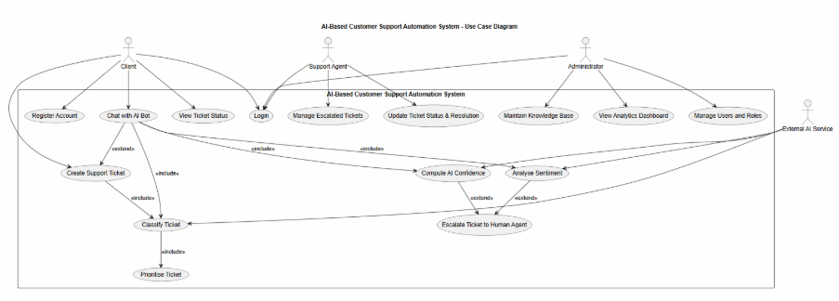

Context Diagram
This context diagram provides a high-level overview of how the AI-Based Customer Support Automation System interacts with external entities. It identifies all major stakeholders: Client, Support Agent, Administrator, Business Owner/Company, and AI Service Provider and shows how each exchanges information with the system. The system itself is represented as a single boundary containing the Web Frontend, Backend API, and Support Database. Clients use the chat and ticket interface, support agents and administrators access dashboards, and business owners review analytics. The Backend API communicates with the External AI Service (OpenAI/Gemini) to perform NLP, sentiment analysis, and response generation. Overall, the diagram clearly illustrates the system’s environment, external dependencies, and the flow of information between human users, system components, and AI services.
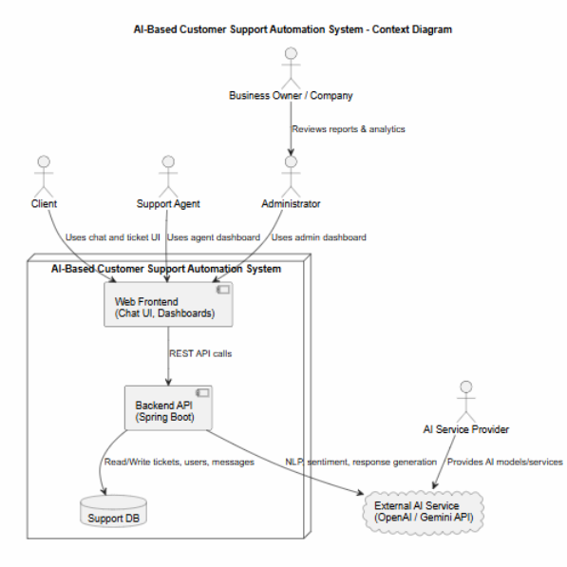

High-Level Architecture / Component Diagram
This diagram illustrates the overall structure of the AI-Based Customer Support Automation System by showing how its major components interact across the three system layers. The Presentation Layer includes the Client Chat UI, Support Agent Dashboard, and Admin Analytics Dashboard, which communicate with backend services through REST APIs. The Application Layer (Spring Boot backend) contains core services such as Chatbot & AI Processing, Ticket Management, Analytics, Knowledge Base, and User Authentication. These services handle business logic and coordinate data processing. The Data Layer consists of relational database tables for users, tickets, messages, and knowledge base entries. The diagram also shows integration with an External AI Service (OpenAI/Gemini) used for NLP, sentiment analysis, and classification. Overall, the architecture demonstrates a modular, layered design that supports scalability, maintainability, and clear separation of responsibilities.
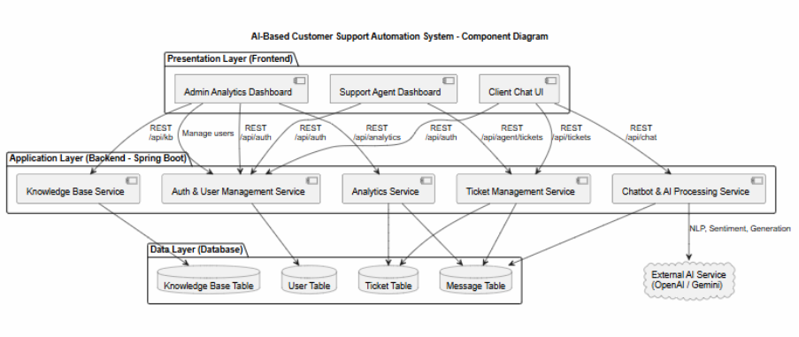

Class Diagram
This class diagram represents the conceptual structure of the AI-Based Customer Support Automation System. It defines the main classes, their attributes, methods, and relationships. Core entities such as User, Ticket, Message, and KnowledgeBaseEntry model the system’s data, while service classes including ChatbotService, TicketService, AnalyticsService, AuthService, and KnowledgeBaseService implement the system’s business logic for message processing, ticket classification, sentiment analysis, authentication, and analytics generation. It includes SystemLog and SystemLogService, which record important system events such as login attempts, ticket creation, escalations, and AI-generated actions. Relationships show how users create tickets, how tickets contain messages, how knowledge base entries are maintained, and how logs are associated with both users and tickets. Overall, the diagram provides a concise and complete view of the system’s data structure and logic components.

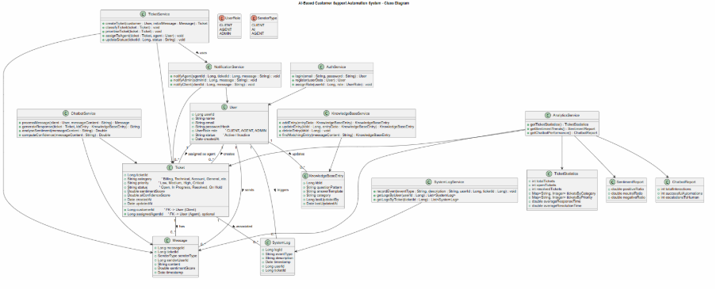

Sequence Diagram (AI chatbot interaction and escalation)
This sequence diagram illustrates how the AI-Based Customer Support Automation System processes a client’s message and decides whether to respond automatically or escalate the issue to a human support agent. When the client submits a query through the chat interface, the ChatbotService first checks the KnowledgeBaseService for a matching entry. If a suitable entry exists, the chatbot generates a predefined response. If not, the chatbot uses the External AI Service to analyse intent, sentiment, and confidence. Based on these results, the system either generates an AI-based response or creates a support ticket through the TicketService. In cases of low confidence or negative sentiment, the ticket is escalated and the Support Agent is notified. This diagram clearly demonstrates the intelligent decision-making workflow between automated AI responses and human intervention.
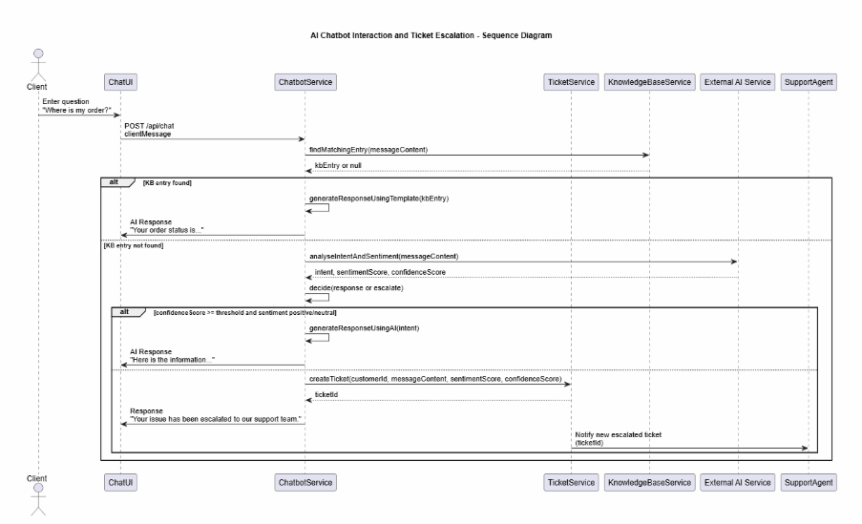

Activity Diagram
This activity diagram illustrates the complete lifecycle of a customer support ticket within the AI-Based Customer Support Automation System. The process begins when a client sends a message through the chat interface. The chatbot first attempts to resolve the issue using the knowledge base and AI-generated responses. If the issue cannot be resolved automatically, the system creates a support ticket, classifies it, assigns a priority level, and performs sentiment and confidence analysis. Based on these results, the ticket may be escalated to a human support agent. The agent reviews the ticket, requests additional information if needed, and provides a resolution. The ticket then transitions through states such as In Progress, On Hold, or Resolved, before finally being closed. The diagram clearly demonstrates how AI automation and human intervention work together to ensure efficient and accurate customer support handling.
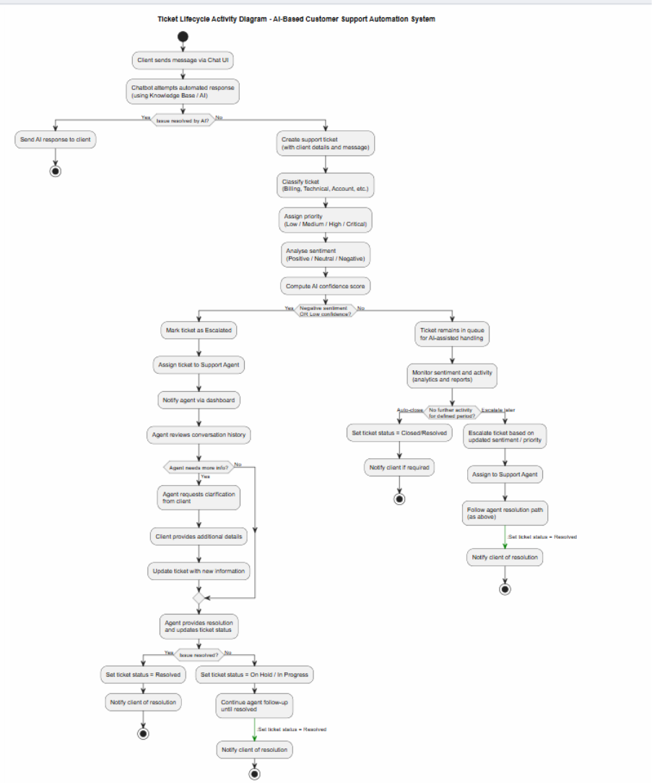

ERD Diagram
This ERD represents the database structure of the AI-Based Customer Support Automation System. It defines the main entities User, Ticket, Message, KnowledgeBaseEntry, SystemLog, and the newly added Notification table and shows how they relate to each other. The User entity stores information for clients, support agents, and administrators. The Ticket entity records customer issues, including category, priority, sentiment score, confidence score, and assigned agent. The Message entity stores all chat interactions linked to a ticket, including AI-generated responses and agent replies. The KnowledgeBaseEntry entity contains predefined question-answer patterns used by the chatbot. The SystemLog entity tracks important system events such as logins, ticket creation, escalations, and AI actions. The new Notification entity stores alerts sent to agents or clients when tickets are escalated, updated, or resolved. Together, these entities form a complete and normalized relational database model that supports automated responses, ticket management, sentiment analysis, human-AI collaboration, and real-time notifications.

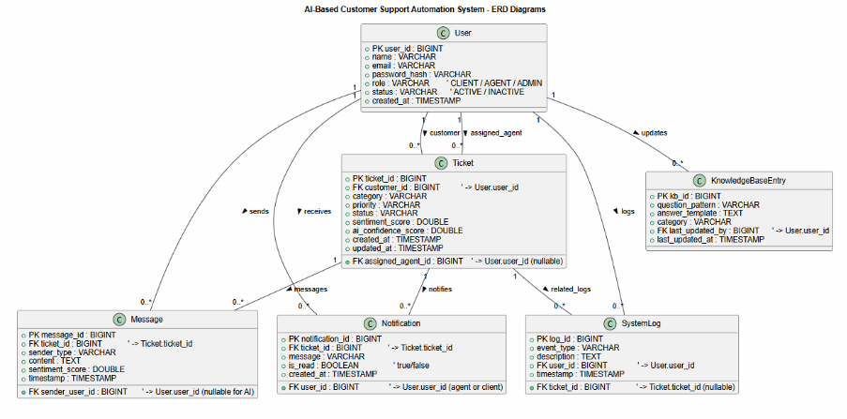

Deployment Diagram
This deployment diagram illustrates how the AI-Based Customer Support Automation System is deployed across different hardware and cloud environments. The client interacts with the system through a web browser, which hosts the frontend interface and communicates with the backend via HTTPS REST APIs. The Spring Boot application runs on an application server and handles authentication, chatbot processing, ticket management, analytics, and knowledge base operations. All persistent data including users, tickets, messages, and knowledge base entries is stored in a relational database on a dedicated database server. The system also integrates with an external AI service (OpenAI/Gemini) for NLP, sentiment analysis, and response generation through secure API calls. Overall, the diagram shows how frontend, backend, database, and AI components work together in a distributed deployment environment.
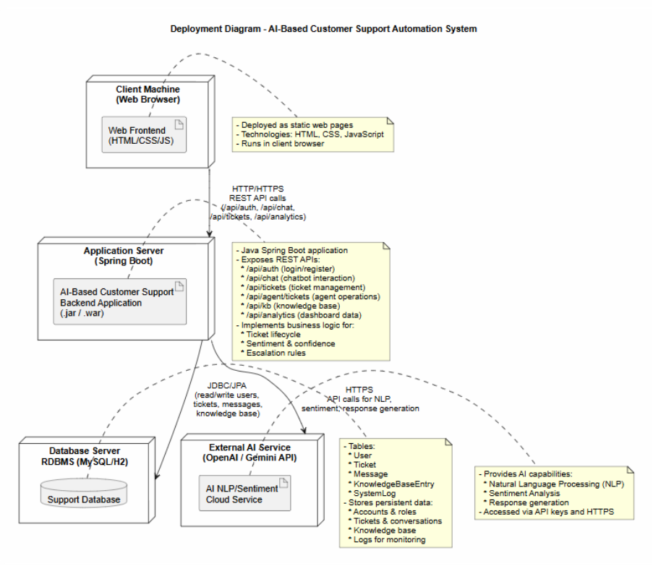

Data Flow Diagram (DFD Level-0)
This Level-0 Data Flow Diagram provides a high-level overview of how data moves through the AI-Based Customer Support Automation System. It shows the main external entities Client, Support Agent, Administrator, and External AI Service and how each interacts with the central system. The Client sends login details, chat messages, and support enquiries, while receiving chatbot replies and ticket updates. Support Agents receive escalated tickets and submit resolution updates. Administrators manage users, update the knowledge base, and request analytics. The External AI Service provides NLP, sentiment analysis, and AI-generated responses. The diagram also includes key data stores such as User Data, Ticket & Message Data, Knowledge Base, and Analytics Data, showing how the system stores and retrieves information. Overall, this diagram illustrates the major data flows and interactions that support automated and human-assisted customer service.
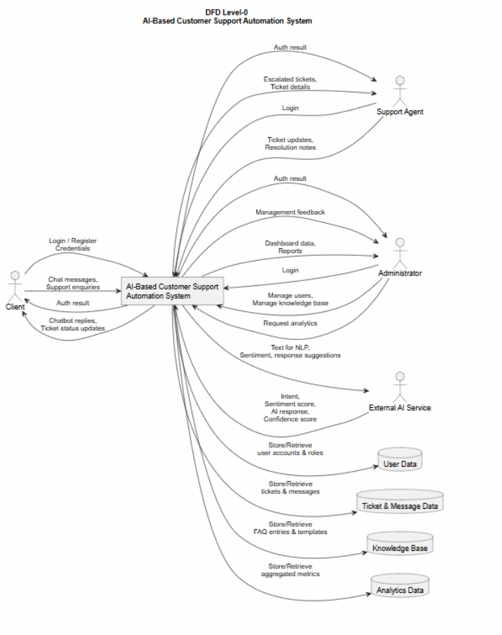

State Diagram
This state machine diagram illustrates the lifecycle of a support ticket within the AI-Based Customer Support Automation System. A ticket begins in the New state and progresses through automated steps such as classification, prioritisation, and sentiment/confidence analysis. If the AI determines that the issue can be resolved automatically, the ticket transitions to ResolvedByAI and then Closed. If the AI detects low confidence, negative sentiment, or a complex query, the ticket moves to the Escalated state and is assigned to a human support agent. The agent then works on the ticket in the InProgress state, requesting additional information from the client if needed. Once the agent provides a solution, the ticket transitions to Resolved and finally Closed. This diagram clearly shows how AI automation and human intervention interact to manage ticket progression.
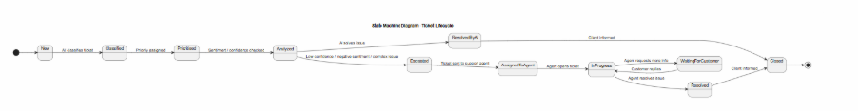

Conclusion
The System Analysis and Design phase has successfully translated the AI-Based Customer Support Automation System proposal into a clear and actionable technical plan. The analysis identified the main stakeholders, user roles, functional and non-functional requirements, and the essential system processes required to automate customer support while still enabling human agents to manage complex or sensitive cases. The design phase then structured these requirements into comprehensive models, including use case, class, sequence, activity, ERD, DFD, deployment, and state machine diagrams.
Overall, the proposed system is feasible, well-structured, and aligned with the project objectives. It adopts a modern three-tier architecture consisting of a web-based frontend, a Spring Boot backend, a relational database, and optional AI service integration for NLP and sentiment analysis. This design provides a strong foundation for implementation, ensuring scalability, maintainability, and efficient support automation.

Reference
- Brandtzaeg, P.B. and Følstad, A. (2017) ‘Why people use chatbots’, in Internet Science. Cham: Springer, pp. 377–392. doi:10.1007/978-3-319-70284-1_30.
- Dlodlo, D. and Sibanda, K. (2023) ‘Automated ticket classification for information technology helpdesks using machine learning’, 2023 2nd Zimbabwe Conference of Information and Communication Technologies (ZCICT), pp. 1–7. doi:10.1109/ZCICT59466.2023.10528578.
- Dwivedi, Y.K., Hughes, L., Ismagilova, E., Aarts, G., Coombs, C., Crick, T., Duan, Y., Dwivedi, R., Edwards, J., Eirug, A., Galanos, V., Ilavarasan, P.V., Janssen, M., Jones, P., Kar, A.K., Kizgin, H., Kronemann, B., Lal, B., Lucini, B., Medaglia, R., Le Meunier-FitzHugh, K., Le Meunier-FitzHugh, L.C., Misra, S., Mogaji, E., Sharma, S.K., Singh, J.B., Raghavan, V., Raman, R., Rana, N.P., Samothrakis, S., Spencer, J., Tamilmani, K., Tubadji, A., Walton, P. and Williams, M.D. (2021) ‘Artificial Intelligence (AI): Multidisciplinary perspectives on emerging challenges, opportunities, and agenda for research, practice and policy’, International Journal of Information Management, 57, p.101994. doi:10.1016/j.ijinfomgt.2019.08.002.
- Følstad, A. and Skjuve, M. (2019) ‘Chatbots for customer service: User experience and motivation’, Proceedings of the 1st International Conference on Conversational User Interfaces, pp.1–9. doi:10.1145/3342775.3342784.
- Gnewuch, U., Morana, S. and Maedche, A. (2017) ‘Towards designing cooperative and social conversational agents for customer service’, Proceedings of the 38th International Conference on Information Systems (ICIS). Available at: https://publikationen.bibliothek.kit.edu/1000077139 (Accessed: 24 July 2026).
- Huang, M.H. and Rust, R.T. (2023) ‘The caring machine: Feeling AI for customer care’, Journal of Marketing, 88(5). doi:10.1177/00222429231224748.
- Journal of Science Engineering Technology and Management Science (2026) ‘AI-powered ticket insights: Bridging NLP and ensemble learning for smarter support’. Available at: http://www.jsetms.com/view_issue.php?title=AI-Powered-Ticket-Insights-Bridging-NLP-and-Ensemble-Learning-for-Smarter-Support (Accessed: 2 August 2026).
- Kitsios, F. and Kamariotou, M. (2021) ‘Artificial intelligence and business strategy towards digital transformation: A research agenda’, Sustainability, 13(4), p.2025. Available at: https://www.mdpi.com/2071-1050/13/4/2025 (Accessed: 29 July 2026).
- Mao, Y., Liu, Q. and Zhang, Y. (2024) ‘Sentiment analysis methods, applications, and challenges: A systematic literature review’, Journal of King Saud University – Computer and Information Sciences, 36(4), p.102048. doi:10.1016/j.jksuci.2024.102048.
- Olujimi, P.A. and Ade-Ibijola, A. (2023) ‘NLP techniques for automating responses to customer queries: A systematic review’, Discover Artificial Intelligence, 3(1). doi:10.1007/s44163-023-00065-5.
- Pedro, J. and Faria, S. (2024) ‘Feeling economy, artificial intelligence, and future jobs: A systematic literature review’, Interciencia. doi:10.59671/ydl8q.
- Reis, J. (2026) ‘Artificial intelligence in customer service: Applications and future directions’, Service Oriented Computing and Applications. doi:10.1007/s11761-026-00500-2.
- Rust, R. (2019) ‘The feeling economy: Managing in the next generation of artificial intelligence (AI)’, California Management Review. Available at: https://www.academia.edu/120022772/The_Feeling_Economy_Managing_in_the_Next_Generation_of_Artificial_Intelligence_AI_ (Accessed: 22 July 2026).
- Taherdoost, H. and Madanchian, M. (2023) ‘Artificial intelligence and sentiment analysis: A review in competitive research’, Computers, 12(2), p.37. doi:10.3390/computers12020037.
- Uzan, S., Freud, D. and Elalouf, A. (2025) ‘Optimizing chatbots to improve customer experience and satisfaction: Research on personalization, empathy, and feedback analysis’, Applied Sciences, 15(17), p.9439. doi:10.3390/app15179439.
- Zangari, A., Marcuzzo, M., Schiavinato, M., Gasparetto, A. and Albarelli, A. (2023) ‘Ticket automation: An insight into current research with applications to multi-level classification scenarios’, Expert Systems with Applications, 225, p.119984. doi:10.1016/j.eswa.2023.119984.
- ‘Hybrid Human-AI Collaboration Models for Digital Workplace Optimization’ (2025) ResearchGate. Available at: https://www.researchgate.net/publication/410822398_Hybrid_Human-AI_Collaboration_Models_for_Digital_Workplace_Optimization (Accessed: 31 July 2026).

Individual Contribution Declaration
The AI-Based Customer Support Automation System Project Proposal was developed collaboratively by all team members. Each member contributed to project discussions, research, analysis, planning, and preparation of the final proposal document. The team worked together to define the project idea, analyse the business problem, identify requirements, plan the project delivery approach, and review the final proposal.
Regular team meetings were conducted every Monday for milestone planning and every Friday for progress reviews. These meetings allowed team members to discuss progress, share ideas, review completed sections, and ensure that responsibilities were distributed fairly.
The contribution of each team member is described below.

Akrishta Ale
Akrishta contributed to the overall project planning, documentation, and frontend-related analysis of the proposed system. Her contributions include:
- Participating in project idea discussions, scope definition, and planning decisions.
- Contributing to the project background, justification, objectives, and expected outcomes.
- Assisting with identifying stakeholders, user roles, and system requirements.
- Contributing to the functional and non-functional requirements analysis.
- Preparing the project delivery roadmap and developing the Microsoft Project Gantt chart, including task scheduling, dependencies, milestones, and resource allocation.
- Contributing to sprint planning, workload distribution, and project organisation.
- Analysing frontend requirements and identifying user interface features for customers, support agents, and administrators.
- Reviewing and editing proposal sections to improve structure, clarity, and consistency.
- Assisting with final document formatting and preparation for submission.

Prajita Bhandari
Prajita contributed to the technical planning, system analysis, and backend-related aspects of the project proposal. Her contributions include:
- Participating in project discussions and assisting with defining the proposed enterprise solution.
- Contributing to the identification of system modules, technical requirements, and project feasibility.
- Assisting with functional and non-functional requirements definition.
- Providing input into backend architecture, database requirements, authentication design, and system security considerations.
- Contributing to the identification of required technologies, tools, and development resources.
- Assisting with defining system components, user interactions, and technical implementation considerations.
- Reviewing project risks, constraints, and quality considerations from a technical perspective.
- Participating in proposal reviews and improving technical accuracy of the document.

Ayush Bhandari
Ayush contributed to project research, AI innovation planning, requirements analysis, and proposal development. His contributions include:
- Participating in initial brainstorming and selection of the AI-Based Customer Support Automation System idea.
- Researching the business value and benefits of AI-powered customer support solutions.
- Contributing to the project background, problem statement, and project justification.
- Identifying innovative AI features including chatbot functionality, sentiment analysis, ticket classification, and automated response generation.
- Assisting with stakeholder analysis, user stories, and product backlog development.
- Contributing to AI technology selection and evaluation of OpenAI/Gemini integration possibilities.
- Assisting with risk identification, assumptions, constraints, and project feasibility analysis.
- Reviewing and improving proposal content to ensure alignment with assessment requirements.

Team Collaboration Statement
All team members contributed actively throughout the preparation of the Project Proposal. Although each member had a primary area of responsibility, important decisions regarding project scope, requirements, planning, risks, quality, and system direction were discussed and agreed upon collectively.
The final submission represents the combined effort of all team members, with equal participation in planning, reviewing, and refining the proposal to ensure it meets the requirements of the COIT13230 Assessment 1 specification.

AI Collaboration Declaration
Generative AI tools were used as a supporting resource during the preparation of this project proposal. AI assistance was used for activities such as brainstorming ideas, improving document structure, refining written explanations, and reviewing the clarity of project documentation.
All AI-generated suggestions were critically reviewed, modified, and adapted by the team members to ensure accuracy, originality, and alignment with the project requirements. The final content, project decisions, technical choices, and contributions represent the team's own understanding, analysis, and collaborative work.

